UNIT: LAUNDRY ESSENTIALS
By J. Pullen |  | NAME
p. 1 of 2
 |  | Date | Date Due:

LAUNDRY ESSENTIALS
Objective: I will identify appropriate clothing care practices.

Directions: Read “Laundry Essentials.” Then complete this worksheet by writing the information in phrases or sentences.

SORTING OUT

Sort your laundry loads according to:

COLOR:

✔
✔
✔

FABRIC AND CONSTRUCTION:

✔
✔
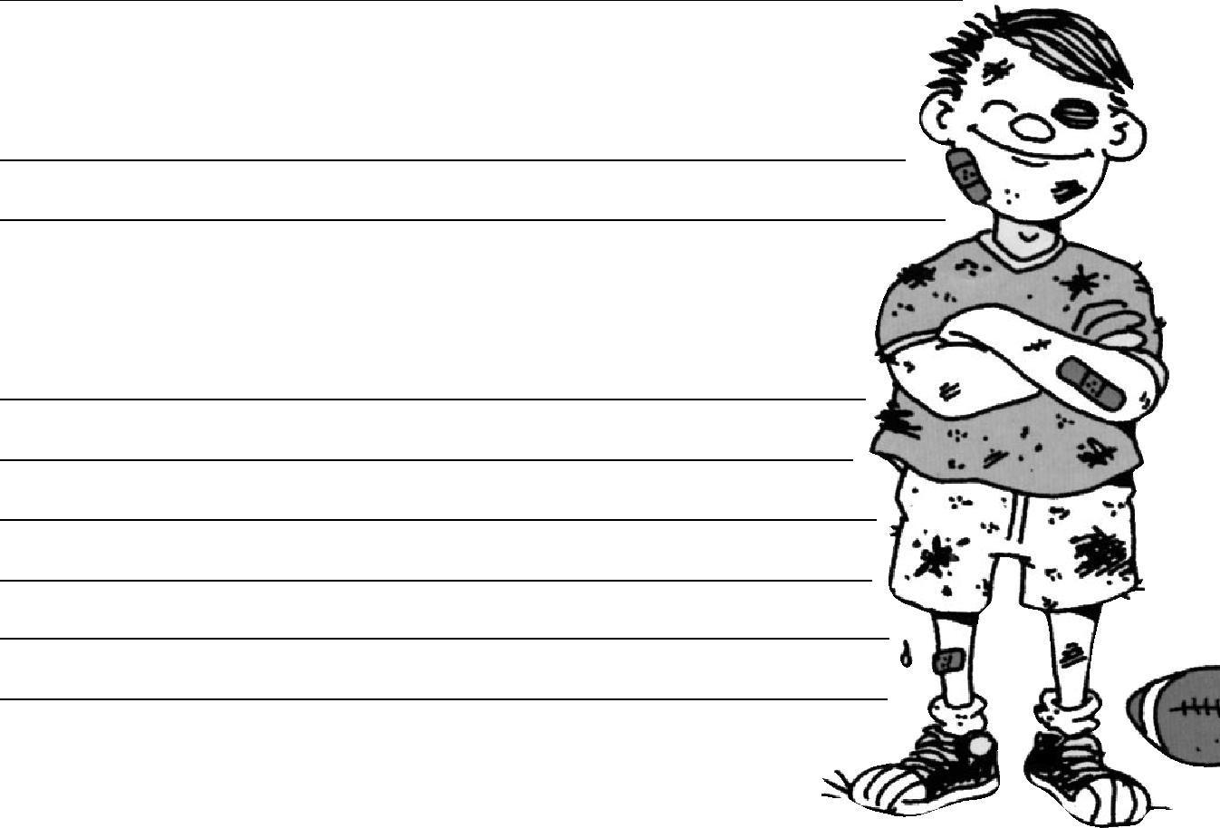

DEGREE OF SOIL:

✔

✔

OTHER CHECKS:

✔

✔

✔

✔

✔

✔

WASHING

When do you need extra detergent?

Continues on back

UNIT: LAUNDRY ESSENTIALS

By J. Pullen

p. 2 of 2

If you have hard water, what type of detergent works best?

When should detergents be added?

Describe the two types of bleach. Which one is a disinfectant that kills germs?

Describe the two ways bleach can be safely added to the washer.

1.
2.

When do you add the clothes to the washer?

In general, how much water should be used for a load of wash?

What does overdrying do to clothes?

1
2.
3.

What is the best way to treat unknown stains?
UNIT: LAUNDRY ESSENTIALS
By J. Pullen |  | NAME
FACS Standards: 2.1.4, 16.2.5
 |  | Date Due: | Parent Signature

BUILDING LAUNDRY SKILLS
Dear Parent or Guardian,

We are asking your son/daughter to work with you to do the family laundry one time. Here is the checklist of steps we want him/her to consider. Please check off the skills practiced and sign the paper. Thank you very much.

Objective: I will practice appropriate clothing care practices.

1. SORTING THE LAUNDRY D O N E

A I sorted the laundry by color. . . . . . . . . . . . . . . . . . . . . . . . . . . . . . . . . . ._________

- I sorted the laundry by fabric and construction. . . . . . . . . . . . . . . . . ._________

- I sorted the laundry by degree of soil. . . . . . . . . . . . . . . . . . . . . . . . . . ._________

- I avoided risk of damage to items by being sure to: . . . . . . . . . . . . . . ._________

  - Empty pockets
  - Shake out loose dirt from cuffs
  - Close zippers, hooks, and eyes, etc
  - Mend rips or tears before laundering
  - Tie strings and sashes loosely to avoid tangling
  - Remove belts, pins or trims that are not washable

- WASHING AND BLEACHING

A I added the detergent as the washer filled. _________

- I used the proper amount of detergent. . . . . . . . . . . . . . . . . . . . . . . . . ._________

- I adjusted the cold water (if used) to 65-85°F (to activate detergent). _________

- I did not overload the washer with clothes, etc. . . . . . . . . . . . . . . . . . ._________

- I added the clothes after agitation began. . . . . . . . . . . . . . . . . . . . . . . ._________

F. When using bleach, I added the proper amount at the correct time: _________

    - Regular liquid bleach: DILUTED 5 minutes into wash cycle or used the bleach dispenser.

    - Color-Safe bleach: measured amount added with detergent.

- DRYING AND IRONING

  - I shook out the clothes before putting them in dryer or on rack/line ._________

  - I checked the clothes to be sure the stains were removed. . . . . . . . ._________

  - I cleaned out the lint filter. . . . . . . . . . . . . . . . . . . . . . . . . . . . . . . . . . . ._________

  - I did not overload the dryer. . . . . . . . . . . . . . . . . . . . . . . . . . . . . . . . . . . ._________

  - I did not overdry the clothes (causes shrinking and wrinkling). . . . . . . ._________

  - I placed clothes on hangers and smoothed them as needed. . . . . . . ._________

  - I ironed clothes as needed, using the recommended heat setting. . ._________

UNIT: LAUNDRY ESSENTIALS

By J. Pullen

NAME

FACS Standards: 2.3.1, 16.2.3 | Date | Date Due:

DECODING CARE SYMBOLS
Objectives: I will read and write care labels using words and symbols.

I will understand textile legislation and labeling in the global economy.

Directions: Care instructions are reported on apparel and home furnishings in words and in symbols. To learn what these symbols mean, try decoding these care labels. Use the ASTM OR CLOROX CARE SYMBOL CHART.
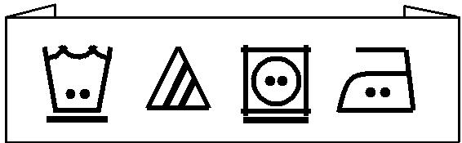
_{1.} 40C

40C
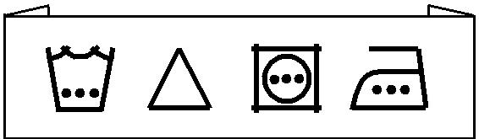

2. 5 0

5 0

Draw a care label in symbols for:
MACHINE WASH WARM, ONLY
_{3.} NON-CHLORINE BLEACH WHEN NEEDED, TUMBLE DRY MEDIUM, WARM IRON IF NEEDED

Continues on back

UNIT: LAUNDRY ESSENTIALS
By J. Pullen | NAME
FACS Standards: 2.3.1, 16.2.3
 | Date | Date Due:
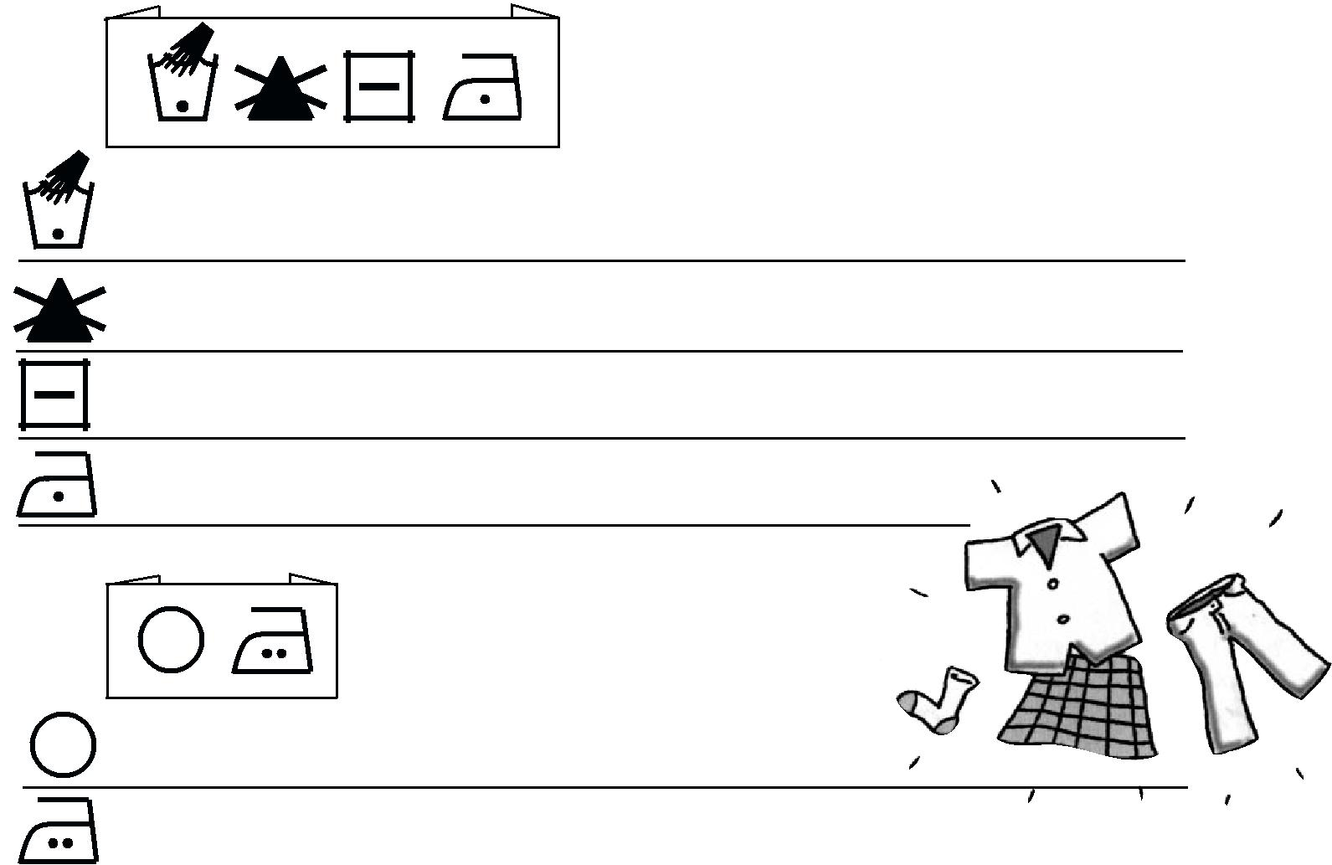

4. 30C

30C

5. _{A}

A

Draw a care label in symbols for:
_{6.} MACHINE WASH WARM, PERMANENT PRESS CYCLE, ONLY NON-CHLORINE BLEACH WHEN NEEDED, TUMBLE DRY LOW, IRON LOW IF NEEDED

Draw a care label in symbols for:
_{7.} DRYCLEAN, PETROLEUM SOLVENT ONLY, LOW IRON IF NEEDED

What is the simple pattern used for the ASTM care symbol system?

8. | TEMPERATURE OF SETTING: |  | MACHINE CYCLE: | No Underline
 | Hot or High | = ____________ | Normal Cycle
 |  |  |  | = ____________
 | Warm or Medium | = ____________ | Permanent Press Cycle | = ____________
 | Coll, Cold or Low | = ____________ | Gentle or Delicate Cycle | = ____________

ASTM GUIDE TO CARE SYMBOLS
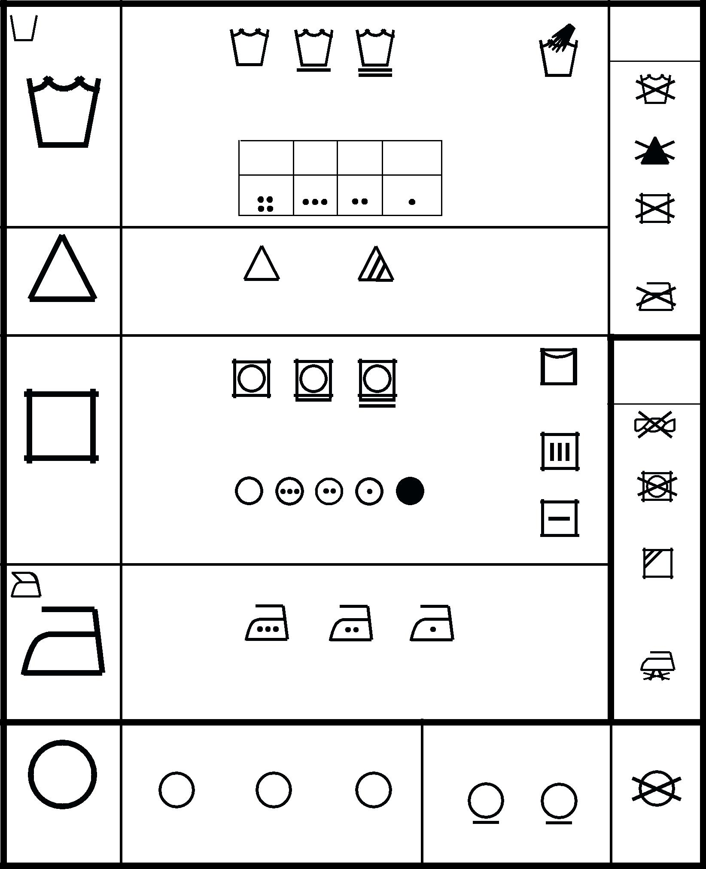
 |  |  |  |  |  |  |  |  |  | Warning
 | Machine |  |  |  |  |  |  |  |  | symbols for
 |  |  |  |  |  |  |  |  |  | laundering
 | wash
 | cycles
 | & | normal | permanent |  |  |  | delicate / |  |  | hand
 |  |  |  | press |  |  | gentle |  |  | wash
 |  |  |  |  |  |  |  |  |  | do not wash
 | Water
 | temperatures | very hot |  |  | hot | warm |  | cool/cold
Wash | (maximum) | (140F) |  | (120F) |  | (105F) |  | (65-85F) |  | do not bleach
 | symbol (s) | 60 |  |  | 50 |  | 40 |  | 30
 | dots & ºC.
 |  |  |  |  |  |  |  |  |  | do not dry
 |  |  |  |  |  |  |  |  |  | (used with
 |  |  |  |  |  |  |  |  |  | do not wash)
 |  | any bleach |  |  | only non-chlorine
Bleach |  | when needed |  |  | bleach when needed
 |  |  |  |  |  |  |  |  |  | do not iron
 |  |  |  |  |  |  |  |  |  | Additional
 | Tumble dry |  |  |  |  |  |  |  |  | instructions
 |  |  |  |  |  |  |  |  |  | (in symbols
 | cycles
 |  |  |  |  |  |  |  |  |  | or words)
 |  |  |  |  |  |  |  |  |  | line dry /
 |  | normal | permanent |  |  |  | delicate / |  |  | hang to dry
 | &
 |  |  |  | press |  |  | gentle
 |  |  |  |  |  |  |  |  |  | do not wring
Dry | Tumble dry |  |  |  |  |  |  |  |  | drip dry
 | heat setting
 |  | any | high medium |  |  |  | low | no heat/ |  | do not
 |  |  |  |  |  |  |  |  |  | tumble dry
 |  | heat |  |  |  |  |  | air
 |  |  |  |  |  |  |  |  |  | dry flat
 | Iron when |  |  |  |  |  |  |  |  | in the shade
 |  |  |  |  |  |  |  |  |  | (added to line
 | needed--dry
 |  |  |  |  |  |  |  |  |  | dry, drip dry, or
 | or steam
 |  |  |  |  |  |  |  |  |  | dry flat)
 | maximum | 200ºC |  |  |  | 150ºC |  |  | 110ºC
 | temperature | (390F) |  |  |  | (300F) |  |  | (230F)
Iron |  | high |  |  | medium |  |  |  | low | no steam
 |  |  |  |  |  |  |  |  |  | (added to iron)
 | Dryclean - normal cycle |  |  |  |  |  |  |  | Dryclean - modified cycle
 | A | P |  |  |  |  | F |  | P | F
Dryclean | any | perchlorethylene |  |  |  | petroleum |  |  |  | do not
 | solvent |  | or |  |  |  | solvent |  |  | dryclean
 | petroleum solvent |  |  |  |  |  | only

Note: As a minimum, laundering instructions include, in order, four symbols: washing, bleaching, drying, and ironing; and, drycleaning instructions include one symbol. Additional symbols or words may be used to clarify the instructions. Actual water temperatures obtained in the home are dependent upon the washing machine settings (hot, warm, cold), regional water supply temperatures, water heater settings, and regulations governing these conditions.
Adapted from ASTM D5489-96c: Standard Guide to Care Symbols for Care Instructions on Textile Products

For voluntary standard information contact: American Society for Testing and Materials, 100 Barr Harbor Drive, West Conshohocken, PA 19428-2959

